**User Cases**

~~-*when user submit request (amin)~~

~~-*when user upload image (amin)~~

-*when user open submission history (details, location,restore,delete) (amin)

-when user forgot password (amin)

~~-*when user pick location (amin)~~

~~-when user opens account page (amin)~~

-*when user submits request (amin)

*Use Case 4: Uploading a help Request*

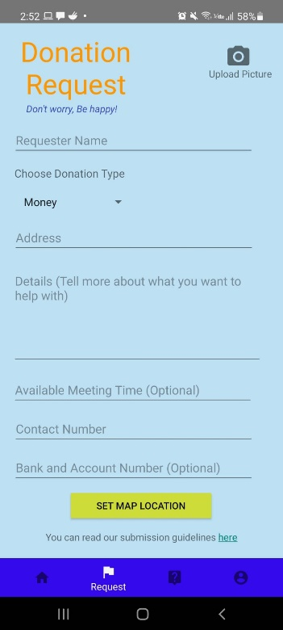

The moment users log into the app, they will be directed to the main page and they can proceed to make their help request by clicking the request button on the bottom of their screen.

On the request page, users will be greeted with the title Donation Request with the slogan Don’t Worry, Be Happy! Along with a few blank fields that they need to fill in in order to upload their request on the map.

Users have to fill in every field with a valid information for their request to be accepted. Any invalid input will be met with error message. Required information that users need to provide is their name, type of donation, address, donation details to describe their request, available meeting time, contact number and bank account information(optional) in case they want the donation to be transferred into their bank account. Users can also click the camera icon to upload pictures along with their request.

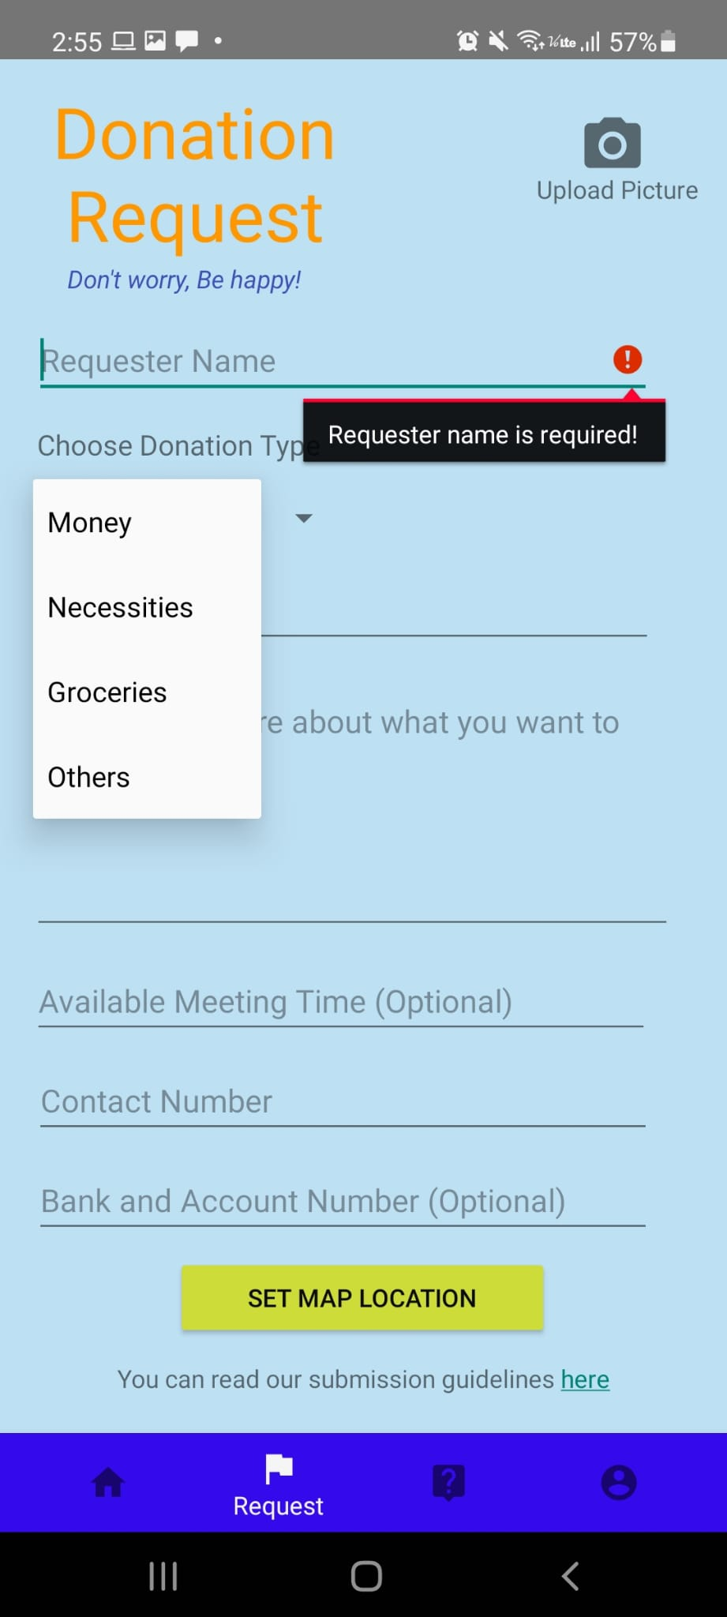

Error message will pop up if the requester name if left empty



Users can choose the type of donation they require from the drop-down menu in the *Donation type* field and choose *others* if they require other help than the option provided.

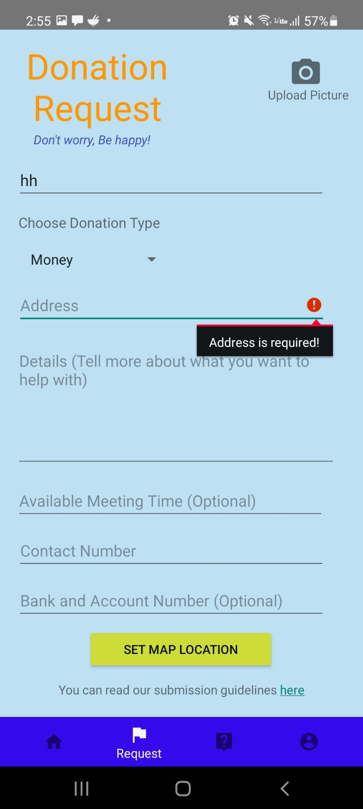

Example of error message that will pop up if the *address* field is left empty.

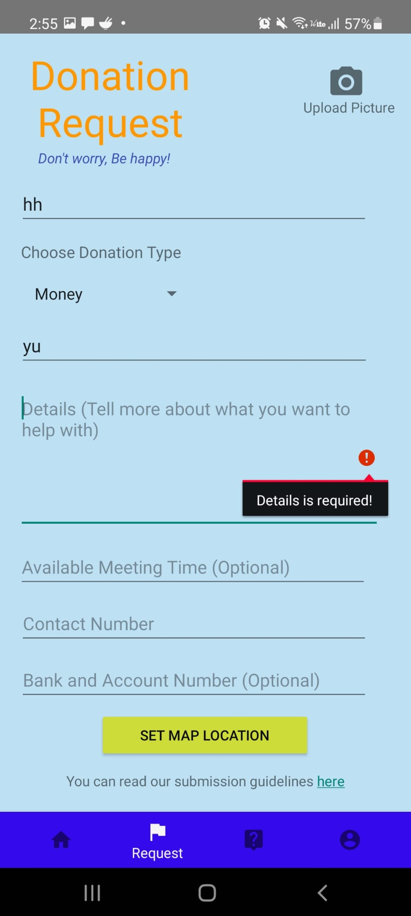

Example of error message that will pop up if the *Details* field is left empty.

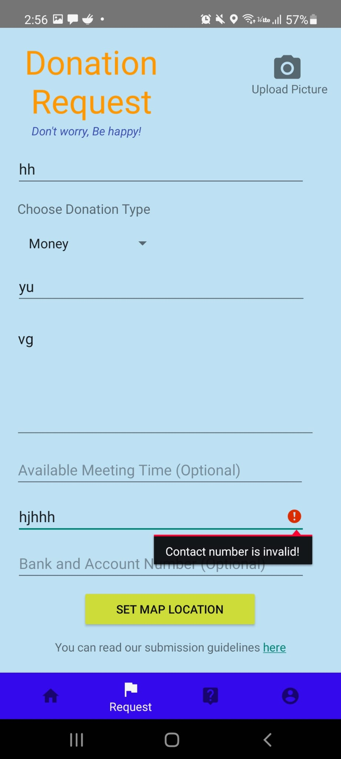

Example of error message that will pop up if the *Contact Number* field is left empty or if invalid input is entered.

When user click the camera icon to upload a picture, they will redirect to the picture upload page. This page helps users to upload the picture to the food bank page. User can also enter the file name to easily upload the picture without redirecting to another gallery to choose the picture manually.

Once user proceeds with upload file button, they will redirect to gallery to choose any picture that they would like to upload as profile picture.

Once user has chosen a picture and click the “Use Image” button, a confirmation window will pop-up asking user whether they are confirmed to use the picture as the profile picture. If user has confirmed the picture, they may press the “OK” button, otherwise they may press the “CANCEL” button to cancel the request.

If there is no file (image) selected, error message will pop-up indicating that there is no file selected and hence the image upload cannot be continued.

The picture uploading process is represented by the flowchart below.

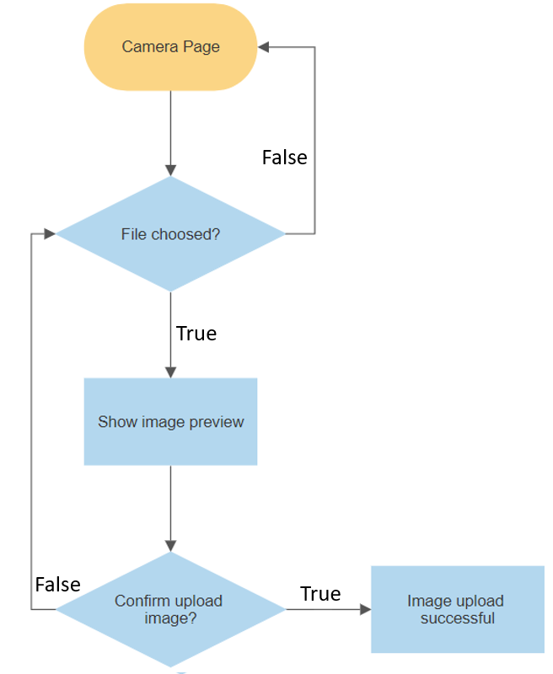

After correctly filling in every field, users can click the set map location button to upload their request to the map for every donor in the area to see and help.

Once user clicked the “Set Map Location” button, they will redirect to the map page with pin on it to indicate where their exact location is. User may also relocate the location pin to the most exact location that they desire to for their organization address.

This confirmation message will pop-up to confirm the marked location (location pin) as the exact location for the organization’s address. User can click “OK” if they confirm to perform the request to use the marked location. Otherwise, they can press “CANCEL” if they would like to cancel the marked location request.

Once user has selected to mark the current location, there will be a location pin with a pop-up message for user to hold and drag the pin to the exact location. User can zoom in and zoom out to have better location precision for the pin.

The error message will pop-up if they tend to use the “Set Location”, but the location pin is not being dragged or set properly by the user. It indicates that user must at least drag the location pin to the exact location to proceed.

This confirmation message will pop-up to confirm the current location as the exact location for the organization’s address. User can click “OK” if they confirm to perform the request to use the current location. Otherwise, they can press “CANCEL” if they would like to cancel the current location request.

The process that user went through when setting up location is represented in the flow chart below.

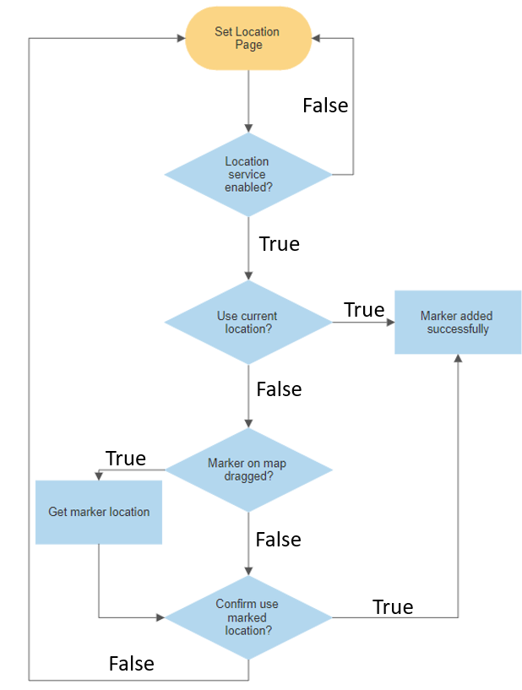

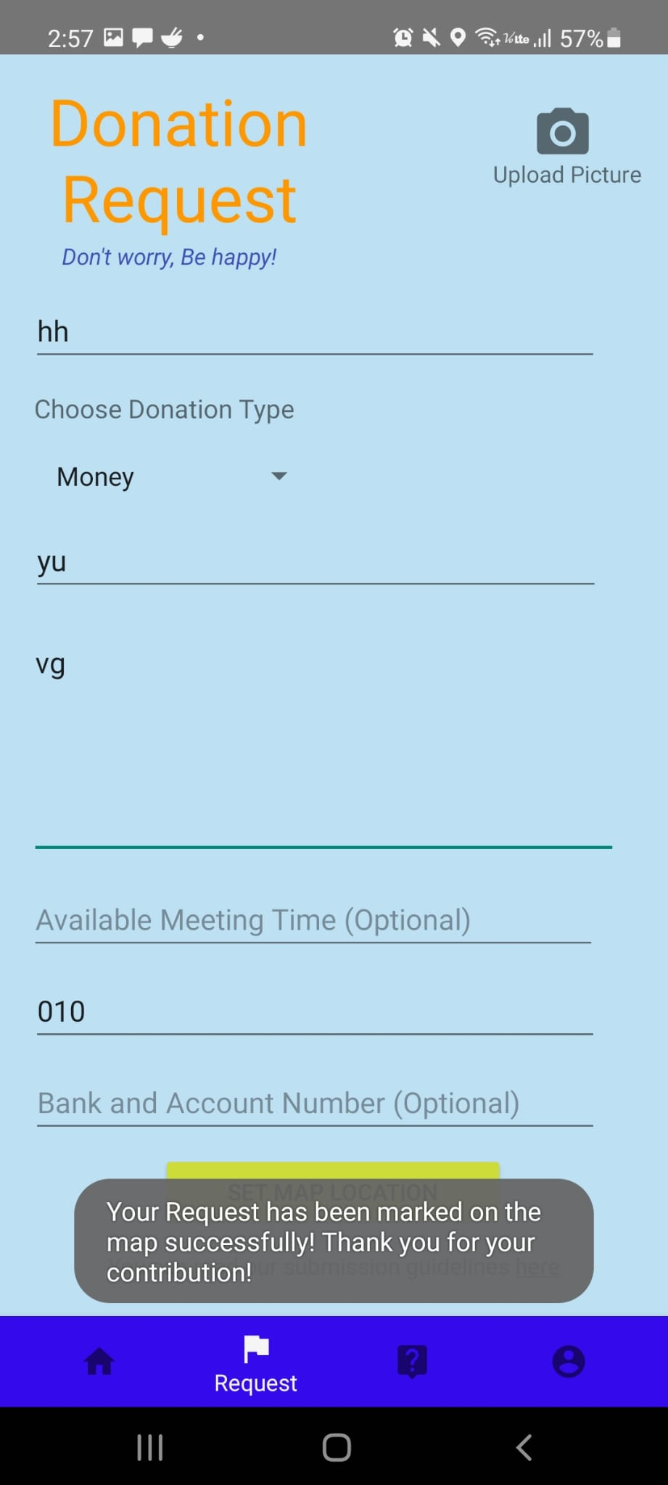

After successfully setting up their location, users will be prompted with pop up message informing that their request had been successfully marked on the map.

The flowchart below describes the process that users went through when uploading their requests.

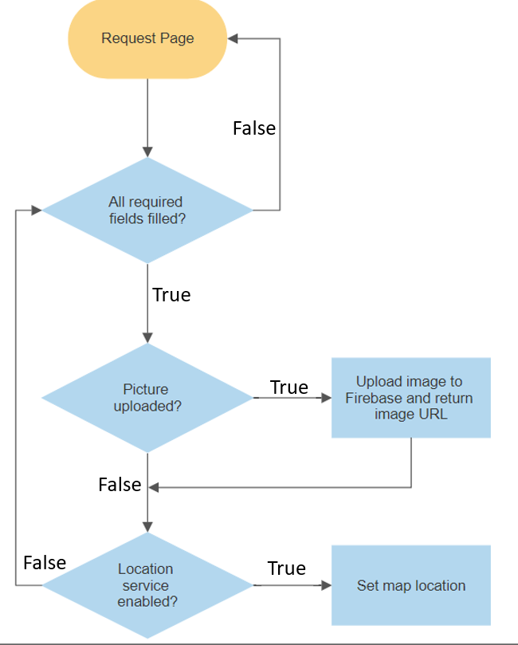

-*when user open submission history (details, location,restore,delete) (amin)

-when user forgot password (amin)

-when user opens account page (amin)

Users can access their account page by clicking the *account* button at the lower right corner of the main page.

Upon clicking this button users will be directed to the account page which look like below.

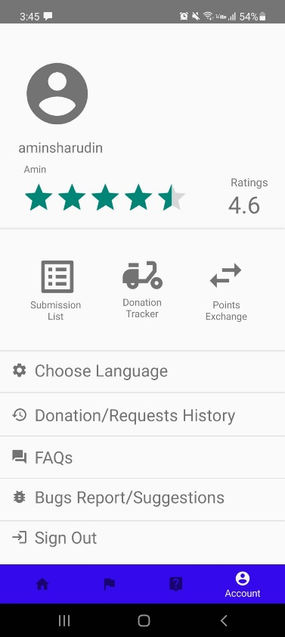

The account page consists of user’s username and profile picture along with stars representing their ratings on the app.

Below that user can access their submission lists, the donation tracker and points exchange page where they can exchange their points for coupons/gifticon provided by the developer.

On this page, users can also utilise a few services provided by the app by clicking on the respective icon.

They can choose their preferred language, access their donation/request history, read on some FAQs, report bugs or offer suggestions and finally they can also sign out from the application.

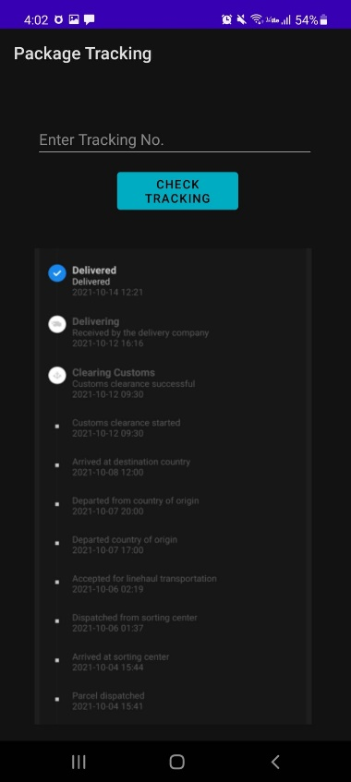

In the case where donation of goods was done through the post, both donors and requester can keep tract of the parcel.

When users click on the donation tracker icon, they will be directed to this page where they can input the tracking number accordingly and the application will display the status of their package.

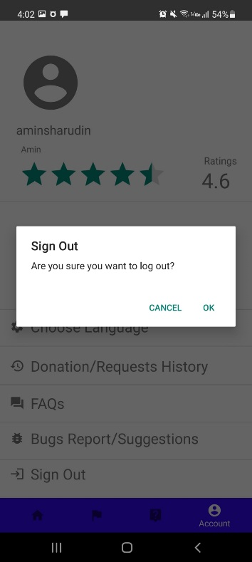

When users clicked the sign out icon, they will be prompted with this pop-up message confirming whether they really want to log out of the application. They can the proceed to log out by clicking *ok*.